**CS 5783**

**(Machine Learning)**

**Assignment 2**

Github: <https://github.com/RafaeAbdullah/CS5683-2>

**By**

**Name: Rafae Abdullah**

**Email:** [**rafae.abdullah@okstate.edu**](mailto:rafae.abdullah@okstate.edu)

1.

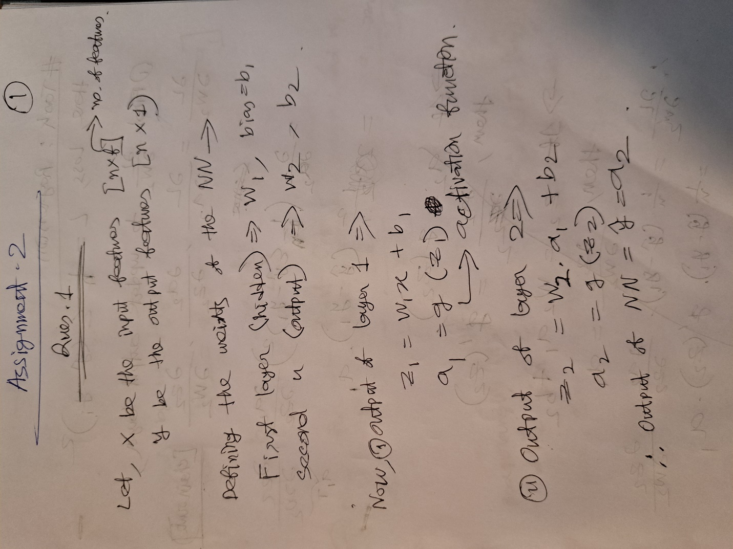

2. On github with comments.